
Major Project Synopsis Report On
“Landslide Detection using Deep Learning Models”

SUBMITTED BY:
Vineet Patel (202200530) Pratham Mir Dutraj (202200521)

Department of Information Technology SESSION: 2025 - 2026
Under the guidance of

Mrs. Sonam Lhamu Bhutia

Designation

DEPARTMENT OF INFORMATION TECHNOLOGY SIKKIM MANIPAL INSTITUTE OF TECHNOLOGY
Majitar, Rangpo, East Sikkim-737136

ABSTRACT

A deep learning-based approach was applied for the classification of landslides using the Landslide4Sense dataset, ( 128x128 pixels) and corresponding binary masks. Convolutional Neural Networks (CNNs), potentially including architectures like ResNet or Vision Transformers (ViT), were trained on pre-processed data involving feature extraction such as RGB channels, Normalized Difference Vegetation Index (NDVI) from near-infrared (NIR) and red bands, and terrain attributes (e.g., digital elevation model channels). Data preprocessing steps included loading HDF5 files via h5py, normalization, and augmentation to handle class imbalance and improve model robustness. By automating multi- channel feature extraction, the need for manual interpretation was minimized, enhancing efficiency and scalability for landslide detection.
The trained models were evaluated using metrics such as accuracy, precision, recall, and F1-score, demonstrating superior performance over traditional machine learning methods. Landslides were segmented and classified into binary categories (landslide vs. non-landslide) with high reliability, highlighting the potential of deep learning for real-world hazard management and risk assessment. The results indicate that this CNN-based classification and segmentation can support early warning systems and contribute to disaster mitigation strategies.

TABLE OF CONTENTS

SL.No | Title | Pg.No
1 | Introduction | 1
2 | Types of Landslides | 2-3
3 | Literature Survey | 4-5
4 | Problem Defination | 6
5 | Objective | 7
6 | Solution Strategy | 8
7 | Dataset Description | 9
7 | Hardware and Software Requirements | 10
8 | Gant Chart | 11
9 | Reference | 12

INTRODUCTION
Landslides are one of the most frequent and destructive natural hazards, causing loss of life, damage to property, and environmental disruption [1]. They are triggered by geological, hydrological, and climatic factors such as heavy rainfall, earthquakes, and human activities like deforestation and construction. With climate change and urban expansion in hilly regions, landslide risks are increasing worldwide [2]. Traditional methods, including field surveys and manual satellite image interpretation, though effective, are time-consuming, labor-intensive, and limited in handling large-scale geospatial data [1]. Recent advances in remote sensing and machine learning have opened opportunities for more scalable and accurate approaches [2]. In this project, we implement a deep learning-based approach for landslide classification using remote sensing and terrain data stored in .hy format for efficient handling of high-dimensional features. A Convolutional Neural Network (CNN) is employed to automatically extract patterns and classify landslide-prone regions. Model performance is evaluated through accuracy, precision, recall, and F1-score, ensuring reliable results. Unlike traditional approaches, CNNs enable automated feature extraction and robust pattern recognition from multi-channel geospatial data, offering a scalable solution for landslide classification and hazard assessment [1].

TYPES OF LANDSLIDES
- Falls:
Falls involve the sudden detachment and free movement of rock, soil, or debris from a steep slope or cliff.
Materials move almost vertically, dropping through the air and collecting at the base of the slope.Weathering, freeze–thaw action, earthquakes, or heavy rainfall that loosen material.Accumulation of rock fragments (talus) at the foot of a cliff; cracks near cliff edges.Can be very fast and destructive, especially in mountainous terrains with steep rock faces.

- Slides(Rotational):
Slides involve the downslope movement of soil, rock, or debris along a distinct plane of weakness (slip surface).Material moves along a curved surface, causing backward tilting of blocks.
Material moves along a flat or planar surface, often as large blocks.Heavy rainfall, earthquakes, erosion at the slope base, deforestation, or construction activities.Tension cracks, tilted trees/poles, scarps, and displaced ground.Can damage roads, houses, and farmland; sometimes slower than falls but can involve huge masses of earth.

- Topples:
Topples occur when a block of rock or soil tilts forward and rotates out of the slope.
Rotation occurs around a pivot point (often near the base).Undercutting of slopes, water seepage, freeze–thaw, earthquakes, or gravity acting on overhanging material.Leaning rocks, cracks behind blocks, overhanging cliffs.Usually localized but can trigger rockfalls or secondary slides.

- Flows:
Flows occur when loose, water-saturated soil, rock, or debris behaves like a viscous fluid and moves downslope.Fast, carries boulders, trees, and debris mixed with water.Finer particles (silt/clay) dominate, moving like wet cement.Slower, involves cohesive soil masses.Intense rainfall, snowmelt, or volcanic activity (lahars).Bulging toes at slope base, lobes of soil, and wet, hummocky terrain.Can be rapid, destructive, and long-traveling, burying settlements and infrastructure.

- Spreads (Lateral Spreads):
Lateral spreads occur when intact soil or rock blocks move horizontally, usually over an underlying weakened or liquefied layer.Extension and fracturing, with blocks drifting apart; often looks like the ground “tearing apart.”Earthquake-induced liquefaction, river undercutting, flooding, or water-saturated weak soils.Wide ground fissures, tilted structures, and horizontal displacements.Particularly damaging to infrastructure like roads, railways, and pipelines; affects large, flat terrain near rivers or coasts.

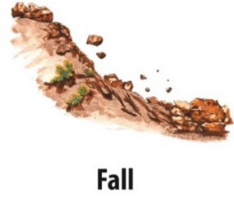

Fig: 1.1 Fig: 1.2 Fig: 1.3

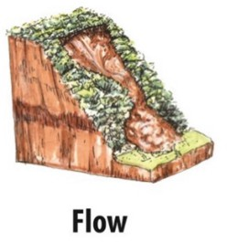

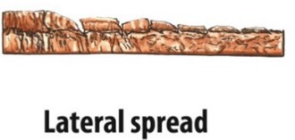

Fig: 1.4 Fig:1. 5

LITERATURE SURVEY


LITERATURE SURVEY



PROBLEM DEFINITION

Automatic Classification of Landslide-Prone Regions: The main challenge is to figure out if a region is landslide-prone using data such as satellite images, geospatial layers, and soil characteristics. Traditionally, experts do this manually, which takes a lot of time and is limited to smaller areas. The key question is how to use computational models to automatically classify regions so that large areas can be analyzed quickly for landslide risk. Using AI, especially computer vision and geospatial analysis, makes this possible by reducing human error and giving consistent results at a large scale. Prediction of Landslide Occurrence Using Multiple Features: Landslides happen due to many connected factors like slope, soil type, rainfall, land cover, and vegetation. The question is whether AI models can combine and learn from all these features to predict landslides better than traditional methods.
This is important because classical models struggle to capture complex relationships, but deep learning and AI are designed to find these hidden patterns. Accuracy of Manual vs. AI-Based Classification: Manual classification is helpful but often subjective, inconsistent, and cannot handle very large datasets. The question is how accurate manual classification really is and how AI can improve it in terms of speed, reliability, and scalability. AI-based systems can make the process faster, more consistent, and reproducible, which is very important for disaster risk managemen and decision-making.

OBJECTIVE

To implement a Convolutional Neural Network (CNN) architecture for automated feature extraction and classification of landslide imagery.

To preprocess and prepare the landslide dataset by resizing, normalizing, and augmenting images for efficient training and testing.
To evaluate the trained model using standard performance metrics such as accuracy, precision, recall, F1-score, and confusion matrix.
To develop a deep learning-based binary classification model capable of distinguishing between landslide and non-landslide images.

SOLUTION STRATEGY

Use a labeled landslide dataset containing landslide and non-landslide images [1]. Preprocess the dataset (resize, normalize, augment) to prepare it for training. Implement a Convolutional Neural Network (CNN) model to automatically learn spatial and textural features from imagery, eliminating the need for manual feature extraction [2]. Train the CNN to classify regions into binary categories (landslide vs. non-landslide), enabling scalable and efficient large-scale analysis. Integrating Multi-Feature Learning for Better Prediction: Incorporate geospatial and terrain features such as slope, soil type, and vegetation (if available) along with satellite imagery for richer input data [1]. Utilize CNN’s ability to capture nonlinear relationships in complex datasets, making the model more effective than classical statistical approaches. Employ feature fusion or multi-channel data input techniques so the model learns not just from pixel-level patterns but also from environmental and geological parameters [2].
Ensuring Higher Accuracy than Manual Methods: Evaluate the trained model using accuracy, precision, recall, F1-score, and confusion matrix to objectively measure performance. Compare model results against traditional/manual classification to highlight improvements in speed, consistency, and scalability [1]. Leverage deep learning’s ability to provide reproducible, unbiased, and automated results, reducing human error and subjectivity in landslide mapping [2].

.

DATASET DESCRIPTION

DATASET LINK : Classification for Landslide Detection (Kaggle)

MAIN FOLDER NAME :

Classification for Landslide (Total number of images present in this folder: 12,544) Total Size 4.93 GB

SUB FOLDER DETAILS :

train_data:
Contains the training images used for model development.
Images are organized with corresponding labels provided in Train.csv. Format available: .jpg (raw images), .npy (preprocessed NumPy arrays). test_data:
Contains the testing images used for model evaluation.
Labels are not directly given; they are used for submission and verification. Format available: .jpg, .npy.

CSV FILES INCLUDED :

Train.csv → Contains training file names with their corresponding labels (e.g., landslide / non- landslide).
Test.csv → Contains test file names for evaluation.
SampleSubmission.csv → A template submission file for Kaggle competitions.

IMAGE SIZE :
Each image is standardized to 256 × 256
pixels Width: 256 pixels
Height: 256 pixels
Horizontal Resolution: 96 dpi Vertical
Resolution: 96 dpi Bit

HARDWARE & SOFTWARE REQUIREMENTS

Hardware Requirements

Processor (CPU): Intel/AMD , with support for GPU acceleration
GPU: High performance GPU (e.g., NVIDIA and RYZEN ); integrated GPU sufficient for basic tasks.
RAM: 8 GB (min), 16 GB or more (recommended for handling large HDF5 datasets smoothly).
Storage: 256 GB SSD (min), with cloud storage integration (e.g., Google Drive) for datasets.

Software Requirements
Operating System: Windows , Linux-based (e.g., Google Colab). Programming
Environment Libraries & Frameworks: Python 3.12.3 (installed via Colab).
Machine Learning: TensorFlow (for CNN models), architecture U-Net NumPy, Pandas, Matplotlib.
Image Processing: h5py (for HDF5 handling), glob (for file management). Data Handling & Visualization: Matplotlib .
IDE / Tools: Google Colab (Jupyter-based), with Google Drive mounting for data access.
Package Manager: pip (for installing TensorFlow and Matplotlib).
Version Control: Git (integrated with Colab

GANTT CHART

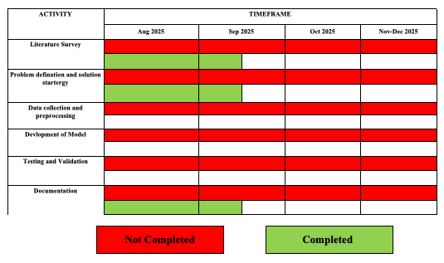

REFERENCE

- Varangaonkar, P., & Rode, S. V. (2024). Landslide prediction with severity analysis using efficient computer vision and soft computing algorithms. Multimedia Tools and Applications.
DOI: 10.1007/s11042-024-19454-8

- Zhou, C., Yin, K., Cao, Y., Ahmed, B., & Li, Y. (2022). Landslide Susceptibility Mapping Using Hybrid Models: A Review and Future Directions. Sustainability, 14(24), 16311.
DOI: 10.3390/su142416311

